**SEETA HIGH SCHOOLS- ST JOSEPH’S SSS NAGGALAMA JOINT UACE GEOGRAPHY SEMINAR.24/09/2022**

**SECTION A**

Questions 1 and 2 are compulsory.

COMPULSORY MAP WORK QUESTION.

1. Study the map extract 1:50,000(UGANDA) KABALE series Y731, edition 4 U.S.D part of sheet 93/4, and answer the questions which follow:
2. (i) Name the feature found at grid reference 327557.

(ii) state the grid reference of Ndaragi Trigonometrical Station (other)

1. Draw a cross section of the area along easting 33 from northing 53 and northing 61 and on it, mark and name:
2. Any two drainage features,
3. Butale ridge,
4. Wide valley,
5. Plantation,
6. Any one communication route.
7. Calculate the
8. Horizontal equivalent
9. Gradient of the cross section.
10. Describe the:
11. relief of the area shown on the map extract.
12. relationship between relief and drainage,
13. relationship between relief and land use in the area shown on the map.
14. Explain the conditions favouring land uses in the area shown on the map.
15. What characteristics are displayed by lake Bunyoyi?

**PHOTOGRAPHIC INTERPRETATION**.

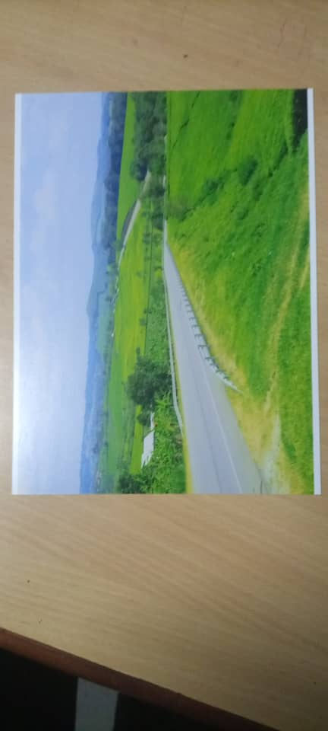

2. Study the photograph provided and answer the questions that follow:

(a) Draw a landscape sketch of the area shown in the photograph and on it mark and name:

* crop land
* settlements
* communication route
* forests
* gently sloping area.

(b) Explain the influence of relief and transport in the area.

(c) Account for the various land uses carried out in the area shown on the photograph.

(d) Examine the influence of main land uses in reducing the effects of climate change.

(e) Giving reasons for your answer suggest an areas in East Africa where the photograph could have been taken.

SECTION B

1. Account for the dominance of chemical weathering in humid areas of East Africa. (25marks)
2. Explain the influence of **igneous rocks** on land form development in East Africa. (25marks)
3. Examine the relevance of **subsidence theory** to the formation of coral landforms in East Africa. (25marks)
4. (a) what is meant by **climate change**. (05marks)

(b) Account for the increased effects of climate change in East Africa. (25marks)

1. Account for the modification of savannah woodland vegetation in East Africa. (25marks)
2. Account for the dominance of savannah vegetation in East Africa.
3. (a) Distinguish between soil catena and soil profile. (6marks)

(b) examine the influence of physical factors in the development of soil profile. (19marks)

10. Explain the processes for the formation of various soil types in East Africa. (25marks)

**Geography paper two 250/2**

1. Study table below showing tourist arrivals in selected countries in 2010 (000 Tourists)

|  |  |
| --- | --- |
| country | No of tourists (000 Tourists) |
| Switzerland | 15000 |
| Tanzania | 5500 |
| kenya | 7740 |
| USA | 24000 |
| Egypt | 9940 |

Source: world geographic scenes page 1201

1. Draw a divergence bar/Divergent line graph to show the above information
2. State the merits and demerits of using the statistical method above
3. Identify the country with
4. Highest
5. Lowest number of tourists arrivals
6. For the country chosen in c(i) above, account for the development of tourism industry.
7. For either Liberia or Canada account for the development of extensive commercial farming
8. For either communes of china or ujaama in Tanzania, Assess the importance of cooperative farming
9. To what extent have physical factors contributed towards the development of fishing in either Northwest pacific or Southeast Pacific.
10. To what extent have physical factors hindered the exploitation of forest resources in either Congo basin or the Scandinavian region
11. For either south Africa or Switzerland, Assess the relative importance of manufacturing sector
12. a) Examine the causes of environmental pollution in the developed world

b) Explain the steps being taken by developed countries to address the problem of environmental pollution

8. For either South Africa or Germany, account for the distribution of transport network

**P250/3**

**GEOGRAPHY**

**(Uganda and Fieldwork)**

**Paper 3**

**July/ August, 2022**

**3 HOURS**

**UGANDA ADVANCED CERTIFICATE OF EDUCATION SEMINAR QUESTIONS 2022**

**GEOGRAPHY**

**UGANDA AND FIELDWORK**

**PAPER 3**

**INSRTUCTIONS TO CANDIDATES**

* Answer **fou**r questions in all
* **One** question from section A and **three** questions from section B
* Any additional question (s) answered will not be marked
* Credit will be given for use of relevant sketch maps, diagrams and specific examples studied in the field.

**SECTION A: FIELDWORK**

1. For any field work study you have carried out
2. State the
3. Topic of study (02mks)
4. Objectives of study (05mks)
5. Explain the activities you carried out before going to the field. (06mks)
6. Draw a transverse of the area studied and on it mark and name:
7. Physical features
8. Land use types (08mks)
9. Explain the practical skills you gained from the field work study. (04mks)
10. For any field work study you have carried out:
11. (i) state the topic of study (02mks)
12. Outline the objectives of study
13. Describe any three steps you took to collect data during the fieldwork study.
14. Explain the relationship between relief and land use in the area studied.
15. Outline the problems you faced during the fieldwork study.

**SECTION B: UGANDA**

1. (a) Describe the processes responsible for the formation of either Lake Victoria or Lake Albert. (10mks)
2. Of what importance are lakes in the economic development of Uganda? (15mks)
3. (a)Describe the characteristics of Nomadic Pastoralism in Uganda. (15mks)
4. Account for the persistence of Nomadic Pastoralism in Uganda. (10mks)
5. (a) Study the table below showing visitors arrival and departures in Uganda 2015-2018 and answer the questions that follow.

|  |  |  |
| --- | --- | --- |
| Year | Visitors arrival (000) | Visitors departure (000) |
| 2015 | 1,303 | 1,310 |
| 2016 | 1,323 | 1,359 |
| 2017 | 1,402 | 1,370 |
| 2018 | 657 | 746 |

***Source: Uganda Bureau of Statistics; 2018***

1. Draw a group bar graph to represent the information given in the table. (08mks)
2. Describe the trend of visitors’ arrival between 2015 and 2018. (03mks)

(c) Assess the impact of the tourism industry to the economic development of Uganda. (14mks)

1. (a) Describe the characteristics of Uganda’s population. (14mks)

(b) Account for the current population distribution in Uganda. (11mks)

7. (a) Describe the state of the manufacturing sector in Uganda. (12mks)

(b) Examine the factors limiting the development of the manufacturing sector in Uganda. (13mks)

8. (a) Examine the threats to wetland conservation in Uganda. (15mks)

(b) Outline the measures that are being taken to conserve wetlands in Uganda. (10mks)